Fahid Chowdhury
Student ID: 11631780
Proposal Peer Review
Assignment 2
ITC209 – Mobile Application Development
Contents
Introduction 2
Clarity of the Proposal 2
1. Table of Contents 2
2. Developer Introduction 2
3. Project Name 2
4. Project Motivation 3
5. Screen Descriptions 3
6. Development Environment 4
7. Sequence Diagrams 4
8. Class Diagram 4
9. Project Requirements 5
10. GUI Mock-Ups 5
Technical Soundness 5
1. Home Page 6
2. Notification 6
3. Automatic setting 6
4. Addressing Tiers 6
5. Exception Flow Missing 7
6. Creativity 7
Difficulty Level 8
1. User Interaction 8
2. Database Saving 8
3. Playing Media 8
4. Push Notifications 9
5. Visualization 9
Overall Suggestions 10
1. Setup Profile 10
2. Label for Buttons 10
3. Reminder/Alert 10
Conclusion 11

Introduction
This document is a proposal review of the project proposal of a fellow student whose project for this subject is a mobile application called H2O. This application is a hydration reminder application which will help the user of this application to remind them to drink water and also record it in their history. This document has been divided into four parts: Clarity of the proposal, technical soundness, difficulty level and overall suggestions. The proposal to be review has been attached below.

Clarity of the Proposal

Table of Contents
At the beginning of the proposal, it can be seen that a table of contents is provided with hyperlinks which are very helpful and makes it easy to navigate the proposal. The page number also makes it helpful reference the pages easily.
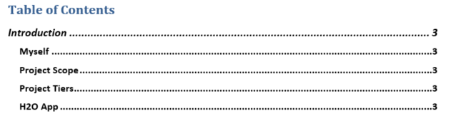
Figure 1 Table Of Contents

Developer Introduction
The introduction of the user and his skills were identified properly and his limitations were also mentioned. This introduction also contains his previous studies which show that the student is ready to learn and create an application for this project.
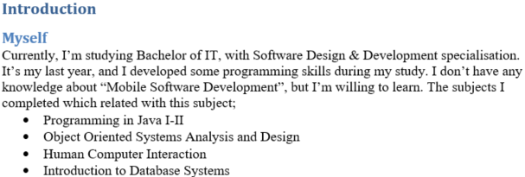
Figure 2 Developer Description

Project Name
While going through the proposal I realised that the project name was not specified properly as a heading or a title of a section rather it was just shown as a logo and mentioned in the project scope. A suggestion for improving this would be to specify at the beginning of the project scope the name of this application.

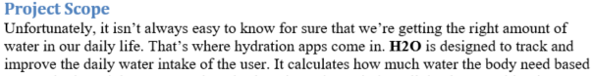
Figure 3 Project Scope

Figure 4 Logo of the application

Project Motivation
The application aims to remind people to drink water and keep a record of their water intake. As these days’ people have become busier they have forgotten the importance of water, so this application’s motivation is a very good one and hence will look to improve the health of the user.
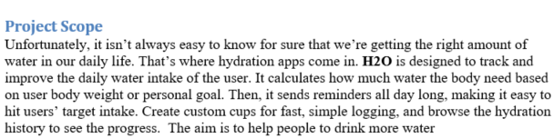
Figure 5 Project Scope

Screen Descriptions
The proposal contained a section which described the screens the application will consist which is very helpful to conceptualize the application. These descriptions were not presented properly and should have been started with a heading like ‘Application Screens’. But this description would be better if it was placed in the GUI Mock-Ups section under the mockups.
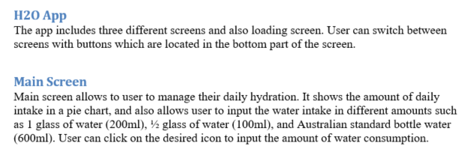
Figure 6 App Screen Descriptions

Development Environment
The student has discussed the development environment which is going to be used for making this project. But the student could have included the usage of SQLite here since the application will make use of databases.
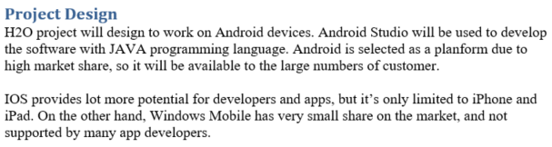
Figure 7 Development Environment

Sequence Diagrams
The sequence diagrams of this application have been labelled and designed properly and all the entity and controller classes have been identified. However, the student could have included the database part of the application in the sequence diagrams.
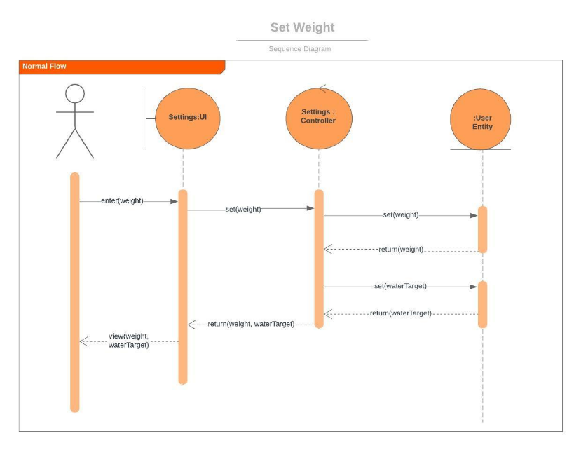
Figure 8 Sequence Diagram (Use Weight)

Class Diagram
The class diagram should contain a class called the User which should contain the details like ‘userWeight’ and ‘waterTarget’, rather than in a class called Settings. The entity classes and the controller classes are not distinguishable in this diagram.
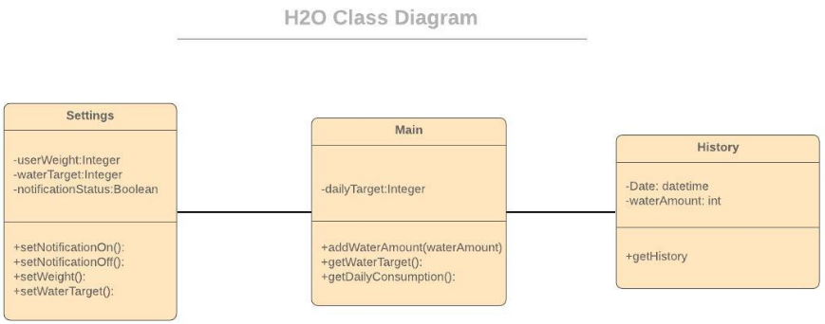
Figure 9 Class Diagram

Project Requirements
The section project requirements are good but it is missing certain hardware requirements like the minimum requirement of RAM required for this application or the processor required by the device.
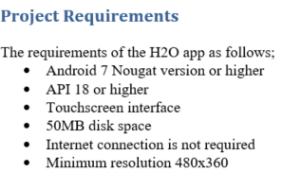
Figure 10 Project Requirements

GUI Mock-Ups
The mock-up screens of the application are designed well and the labels on the designs also help in understanding the mock-up. My suggestion for this section would be to have storyboard to at least show the normal flow of the application. As mentioned earlier, it would have been nice to have a caption as well as a description of the screen in this section rather than in the project description section. It would have also been nice to add a heading which would give us an idea of the screen which is being shown.
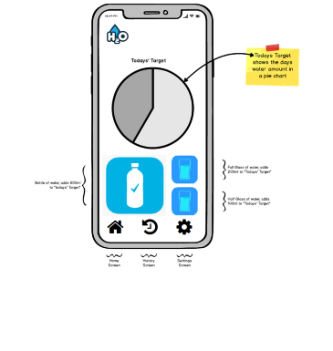
Figure 11 Mock-Up (Description Missing)

Technical Soundness

Home Page
The use of the word homepage was used very less and instead ‘Main Screen’ was used which is not the best term to be used in this context. The home page is the screen which will be the first screen displayed after the application is launched.
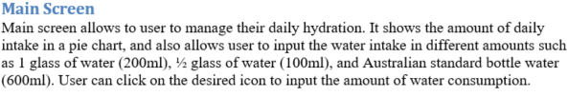
Figure 12 Main Screen Description

Notification
The term notification is used in the settings screen, but it is not described what type of notification it is. Is it a type of alert? Or a reminder? If it is a reminder when is it supposed to be triggered? What are the notifications supposed to convey? Need more clarification of the term notification used.
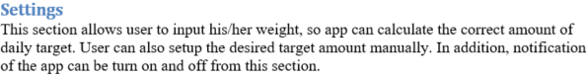
Figure 13 Settings Screen Description

Automatic setting
The user interaction of this application was not explained properly, for example, when will the user enter their weight and target. As the student has claimed that the daily water intake target will be automatically calculated from the user’s weight, the application needs to log the weight first. How will it be calculated? More clarification of this term should have been provided in the project description.
Figure 14 Target Water set automatically

Addressing Tiers
A major issue I found in this proposal was in the project tiers which will be addressed in this application were mentioned but how they were going to be addressed was not explained at all. A suggestion for this would be to explain how the tiers will be used in a use case. For example, the tier two feature which is visualization will be implemented in the use case ‘View History’ which will show the hydration history of the user in the form of a chart.
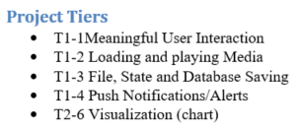
Figure 15 Project Tiers

Exception Flow Missing
I have also noticed that the student has not added the section Exception Flows in the Full Use Case Descriptions. This section should have contained details like what happens when there is an exception like the user does not set their weight. Does it set a default weight?
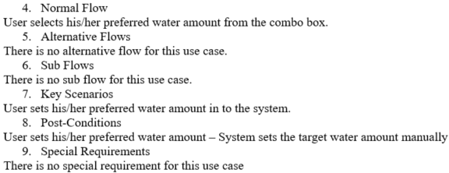
Figure 16 Missing Exception Flow in Full Use Case Description

Creativity
The idea of this application is good although there are similar apps in the market those are too complex to understand for technically challenged users, so it would be nice to see a simpler application of the same idea. But this application could have more features and the user interface could contain more technical components like buttons to add manual water intake and labels to describe icons. Additionally, the mockups could also have screen titles which would represent the purpose of the screen.
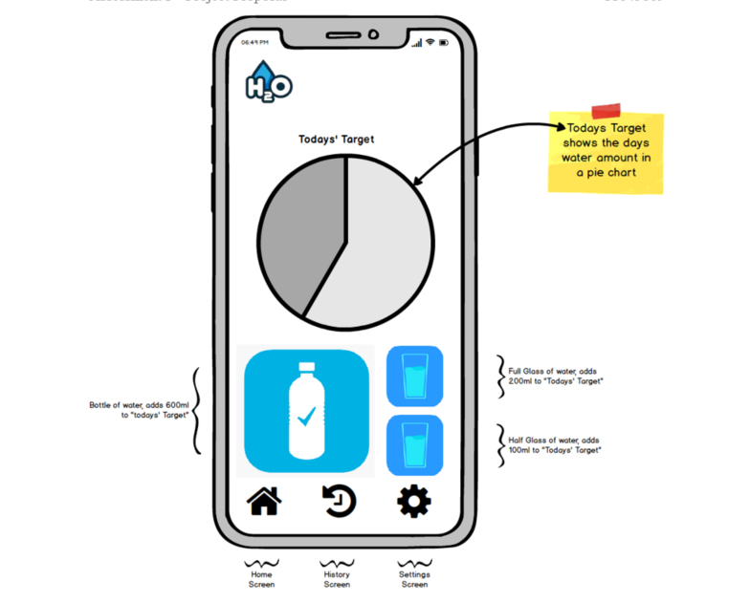
Figure 17 Missing Title in GUI

Difficulty Level

User Interaction
The user interaction feature of this application looks pretty simple but using the combo box maybe a bit complex for the student but since the student has advanced knowledge of Java, it should not be a major challenge. Also adding a water consumption using the icon as a button is not too complex.
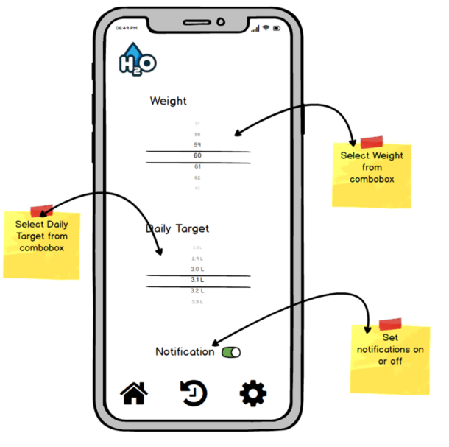
Figure 18 Combo Box in Settings Screen

Database Saving
The database feature of this application will save the weight and target water which will also be comparatively easy by using SQLite which should have been mentioned in the project design. Although, the student might face a challenge in coding for a different type of database compared to what was learnt in Java.

Playing Media
Assuming that the student is addressing the loading and playing media feature by displaying icons like the logo of the app and also the water container icons, this should be easy and not too complex (The student did not mention how the tiers will be addressed).
Figure 19 Main Screen of the application

Push Notifications
The push notifications of this application are not explained properly in the proposal so the difficulty of this feature cannot be discussed thoroughly. But assuming that the alerts will be based on certain times it needs to work with the clock system of the device which could be a challenge.
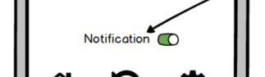
Figure 20 Notification Setting

Visualization
The student may face a few challenges while creating charts for this application which is a feature of tier 2 because from this proposal it seems like the student is going to create this graph from scratch which will make the code complex.
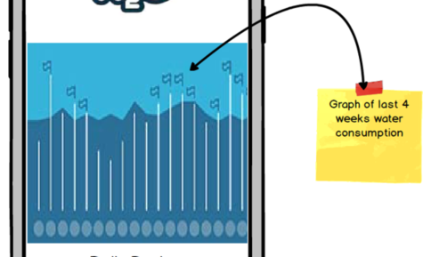
Figure 21 Chart of water consumption
Overall the difficulty level of this application is average which is good enough for this subject because the student is learning to create a mobile application for the first time, as mentioned in the introduction of the proposal and hence a complicated application would be too difficult for the student.

Overall Suggestions

Setup Profile
One issue I found with this proposal is that the first available screen of this application after launch will be the input water consumption record. But it was not mentioned what happens when the user starts up the application for the first time. For example, when will the user set the weight and target water consumption? What value will it show when the user starts the application without setting up the profile? These questions are not addressed in this proposal.

Label for Buttons
The screens need to have a label on the icons or else the technically challenged users will have a tough time using this app. This can be addressed by adding labels under or above the icons which will help the user in better understanding the user interface.
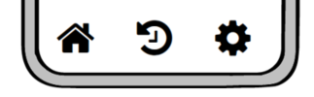
Figure 22 Navigation bar of this application

Reminder/Alert
The notification feature of this application is not discussed extensively in this proposal which is not good. When will the notification be displayed? At the end of the day? At certain time intervals? Even on the setting screen on the user interface does not provide options like at what time or how the alert will be triggered. This issue needs to be addressed. The suggestion for this would be to keep a screen which will let the user specify the times when they will be reminded to drink water or record their water consumption.
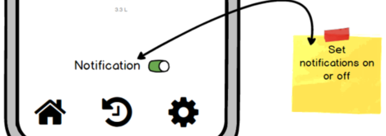
Figure 23 Notifications of the application
Considering that these mockups are only concepts the student can further change it and add all the appropriate components to the screens like labels in the future as the development of this application will commence.

Conclusion
Considering the student is making an application for the first time this application is very good and contains details to let the readers conceptualize the system. The presentation of the report was very good apart from the Mock-Ups (Needed descriptions) and it contained the important components of this application. The content of the proposal was too general at times which showed some inconsistency in the proposal. The motivation for the application is great and has the potentially affecting the user’s health positively. However, I felt that some of the optionality of the system could have been discussed more.

